Chapter 5, Problem 65

Find v_{o} in the op amp circuit of Fig. 5.92.
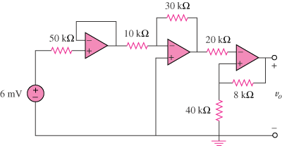
+
–

Figure 5.92
For Prob. 5.65.

